Clinical Guideline for:
NEONATAL RESUSCITATION

Author of Clinical Guideline |  |  | David Bartle, Neonatal Consultant
Directorate/Department responsible for Clinical Guideline |  |  | CWH/Neonatal Unit
Contact details |  |  | david.bartle@nhs.net
Version number |  |  | 7.0
Replaces version number |  |  | 6.0
Date written |  |  | August 2008
Dates revised |  |  | May 2011, February 2015, July 2017,  May 2024, October 2024 (made cross-site), December 2025
Approving body and date approved |  |  | Neonatal Unit Management & Governance Meeting: 11/05/2024  Maternity Governance Forum: 19/06/2024  Perinatal Guideline Group: 25/11/24  Perinatal Governance Group: 05/01/26
Review date (3 months prior to expiry date) |  |  | 05/07/2030
Expiry date |  |  | 05/01/2031
Date document becomes live |  |  | 01/02/2026

Neonatal resuscitation algorithm

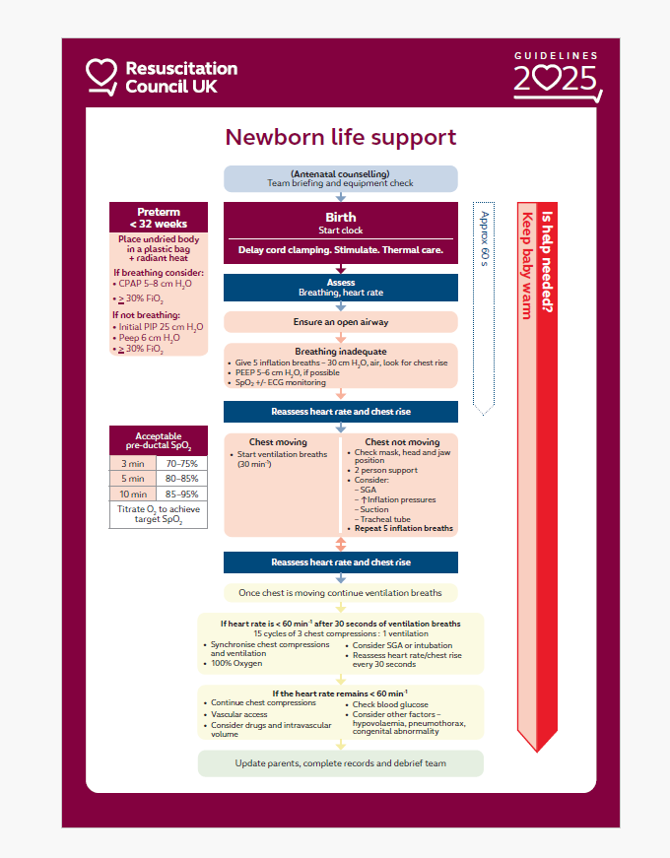
If heart rate is increasing
Stop compressions
Continue ventilation breaths at about 30/minute until baby is breathing adequately
Thermoregulation
maintain temperature between 36.5 – 37.5°C

Newborn Life Support Algorithm (2025). Resuscitation Council UK.

KEY POINTS (NLS 2025)

- It is reasonable for teams to initiate resuscitation of an infant outside the delivery area using the guideline most familiar to the team (either NLS or PLS) whilst summoning appropriate help and switching algorithm in a timely fashion if necessary. It is vital for the whole team to be completely clear on the approach used.
- The guideline acknowledges the paucity of resuscitation data available from extremely preterm infants, especially those < 25 weeks, and cautions that these guidelines are based upon evidence from predominantly older gestational ages, which limits applicability to extremely low gestational ages. However, these guidelines remain a reasonable approach to use for extremely preterm infants < 25 weeks.
- Telemedicine can provide remote advice, and health systems should consider how this can be used.
- Equipment should be easily accessible and organised in a standardised way; consider human factor elements when organising equipment and training to maximise efficiency and minimise time delays.
- Although recommendations about delayed cord clamping (DCC) have not changed significantly, there is even more emphasis on its importance for all newborn infants, especially preterm infants. In newborn infants needing resuscitation, if the cord is intact, resuscitation is impractical; clamp the cord for < 30 s to minimise delay to necessary interventions.
- The guideline reinforces not milking the cord in preterm infants < 28 weeks and focuses on trying to perform delayed cord clamping if possible. Cut cord milking is acknowledged as a reasonable alternative if > 28 weeks and DCC is not possible.
- There is a reduced emphasis on skin colour during initial assessment. This reflects the subjective nature of detecting cyanosis or pallor, especially in different skin tones.
- The guideline recognises the increasing role of ECG as a continuous method of HR evaluation, which is more precise than other methods. However, auscultation with a stethoscope remains a reasonable first option.
- Use the two-person method of airway support (jaw thrust) if sufficient providers are available, as this approach is more effective than the single-person technique.
- A supraglottic airway should be considered if face mask ventilation is ineffective.
- If there is no HR response, the chest is not moving with inflations despite airway opening techniques, increase inflation pressure.
- Reduce inflation pressure when chest movement and clinical improvement are seen.
- Use video laryngoscopy for tracheal intubation (if equipment and training allow). This reflects evidence of increased first attempt and increased overall success in tracheal intubation when video laryngoscopy is used. A conventional direct laryngoscope should be available and remains a reasonable alternative.
- Apply an appropriately fitting nasal interface or a face mask connected to a device for providing positive pressure ventilation.
- CPAP and PEEP are now recommended at a level of 6 cm H₂O.
- This guideline acknowledges that CPAP may be considered in infants > 32 weeks GA with respiratory distress if they require supplemental O₂.
- Initial oxygen concentration according to gestation has been simplified:
  - Infants ≥ 32 weeks needing respiratory support: start with 21% O₂
  - Infants < 32 weeks: start with ≥ 30% O₂
- SpO₂ target ranges incorporating newer data from preterm infants, in addition to the established data from mostly term infants before DCC was standard practice, now result in a target range of acceptable SpO₂. Reduce O₂ if saturations exceed 95%.
- When chest compressions are performed, a supraglottic airway or tracheal tube should be considered, depending on training and experience.
- The time intervals of intravenous or intraosseous adrenaline have been simplified to giving every 4 min.
- Sodium bicarbonate has been removed from the 2025 guideline
- The guideline acknowledges the potential for harm from both hypoglycaemia and hyperglycaemia. There is greater emphasis on checking blood glucose during resuscitation and treating only if it is low, rather than empirical treatment of presumed hypoglycaemia during resuscitation. When hypoglycaemia is treated, the bolus dose of glucose is 200 mg kg-1 10% glucose (2 mL kg⁻¹), which aligns with the RCUK Paediatric Guideline.
- The guideline considers out-of-hospital births, especially when unexpected and/or preterm birth. It highlights key considerations and differences when managing newborns in this setting. It addresses the challenges of thermal care and describes differences in equipment and approach, including safe transfer to hospital.
Newborn resuscitation and support of transition of infants at birth Guidelines | Resuscitation Council UK

CONTENTS

1.  2.  3.  4.  5.  6.  7.  8.  9.  10.  11. | INTRODUCTION…………………………………………………………………………….  BACKGROUND……………………………………………………………………………..  AIMS………………………………………………………………………………………….  NEWBORN RESUSCITATION……………………………………………………………  STAFF AVAILABLE……………………………………………………………………….  DELIVERIES REQUIRING A PAEDIATRICIAN TO ATTEND………………………..  WHEN SENIOR HELP SHOULD BE REQUESTED……………………………………  EQUIPMENT…………………………………………………………………………………  PRETERM DELIVERIES…………………………………………………………………..  REFERENCES ……………………………………………………………………………..  MONITORING COMPLIANCE WITH THIS GUIDELINE………………………………  Appendices (CHECKLISTS CURRENTLY BEING REVISED BY MATERNITY) | 5  5  5  5  5  6  6  7  7  8  8

- INTRODUCTION

  - This clinical guideline is designed to provide advice, guidance and direction to staff whilst leaving room for professional judgement, and adaptation, to fit individual circumstances.

- BACKGROUND

  - Most infants transition to extrauterine life without any interventions. Eighty five percent breath spontaneously, 10% respond to drying, stimulation and airway opening manoeuvres and 5% responds to positive pressure ventilation. Rarely do infants need chest compressions and drugs with good aeration of the lungs. However, it is impossible to predict, prior to delivery, which babies will require resuscitation. It is therefore essential that appropriately trained staff are immediately available at all times and that the equipment is present and ready to use. The need for resuscitation is of course much higher in preterm infants.
- AIMS
  - To summarise and signpost to RCUK NLS guidelines

3.2 To clarify local processes

- NEWBORN RESUSCITATION
4.1 This should be performed in accordance with the Resuscitation Council (UK) guidelines:
Newborn Life Support, resuscitation and support of transition of babies at birth (2025). Newborn resuscitation and support of transition of infants at birth Guidelines | Resuscitation Council UK
4.2 This information is also provided on a laminated sheet present on all resuscitaire, with all home birth equipment and neonatal resuscitation trolleys.
- STAFF AVAILABLE

  - For any baby requiring resuscitation, place a neonatal emergency call by dialling 2222 and state location.

Eastern
Tier 1
24 hours a day there is a tier one doctor or ANNP trained in neonatal resuscitation on site and responsible only to the neonatal unit and maternity services. Contact via neonatal SHO bleep 745.
Tier 2
If further assistance is required a tier 2 doctor or ANNP with training in neonatal resuscitation is available on site 24 hours a day. Contact via the neonatal registrar bleep 853.
Neonatal Consultant
A senior paediatrician with experience and training in neonatal resuscitation is always available but out of hours may not be present on the hospital site. They can always be contacted via switchboard or via telephone numbers held in the NNU staff base
Senior neonatal nurse
A band 6 neonatal nurse (neonatal unit coordinator) trained in neonatal resuscitation is on site 24 hours a day. Contact via bleep 531. This bleep is linked to the neonatal registrar bleep so that if there is an emergency bleep to the registrar the neonatal nurse coordinator will also respond.

Northern
Tier 1
08:30-21:00 hours a day there is a tier one doctor trained in neonatal resuscitation on site and responsible only to the neonatal unit and maternity services. Contact via neonatal SHO bleep 270.
Tier 2
If further assistance is required a tier 2 doctor trained in neonatal resuscitation is available on site 24 hours a day. Contact via bleep 428 (during the day and bleep 270 at night the neonatal registrar carries).

Neonatal Consultant
A senior paediatrician with experience and training in neonatal resuscitation is always available but out of hours may not be present on the hospital site. They can always be contacted via switchboard.

Neonatal nurse
A neonatal nurse trained in neonatal resuscitation is on site 24 hours a day based on SCBU. Contact via bleep 428 at night 21:00-08:30. Depending on staffing/ how busy the unit is the nurse's try to support the doctors and come to deliveries if required and assist doctors in brining baby's up to the unit.

- DELIVERIES REQUIRING A PAEDIATRICIAN TO ATTEND
6.1 A paediatrician should attend the following deliveries:
- All preterm births (<37+0)
- Instrumental delivery (forceps or ventouse)
- Breech vaginal delivery
- Thick or particulate meconium
- Non-reassuring CTG
- Multiple birth by any mode of delivery
- Fetal abnormality with antenatal plan for paediatrician to be present at delivery
- Emergency Caesarean Section (call 2222 and request emergency bleep for category 1 caesarean section)
- Shoulder Dystocia (call 2222 and request ‘obstetric emergency’ and ‘neonatal emergency’ bleeps)
Eastern
If a paediatrician is required the Midwife should contact the neonatal SHO on bleep 745. Please tell the SHO why they are required, when the delivery is likely to occur and in which room.
If neonatal support is required urgently please bleep 2222 and request a ‘neonatal emergency’ bleep

Northern
If a paediatrician is required the Midwife should contact the neonatal SHO on bleep 270 (No SHO at night so this bleep is held by the Reg). Please tell the SHO why they are required, when the delivery is likely to occur and in which room.
If neonatal support is required urgently please bleep 2222 and request a ‘neonatal emergency’ bleep

- WHEN SENIOR HELP SHOULD BE REQUESTED

7.1 Middle grade doctor should be in attendance for:
- All deliveries less than 32 weeks gestation.
- Delivery of any infant known to be at increased risk of requiring resuscitation e.g. antenatally diagnosed condition, poor fetal monitoring, size.
- If the initial assessment reveals no heart rate or severe bradycardia.
- If a newborn does not respond to repeat inflation breaths with repositioning.
- If at any time senior help is required for any reason.

7.2 Consultant should be informed of:
- All deliveries baby under 30 weeks.
- And aim to be present for all deliveries under 28 weeks
- If a baby with a significant anomaly diagnosed antenatally is going to deliver locally rather than as planned at a tertiary centre e.g. diaphragmatic hernia, complex congenital cardiac disease.
- If unable to establish an airway or chest movement and/or if preparing to intubate.
- If the resuscitation requires the use of drugs.
- If at any time senior help is required for any reason.

- EQUIPMENT
- All equipment should be maintained and immediately ready for use
- It should be checked in line with the hospital resuscitation policy; opened resuscitaires/trolleys daily, sealed facilities weekly. Home birth equipment, weekly. Cleaning schedules must be completed.
- Equipment must be available in all care settings-Labour Ward, Maternity Theatre, Postnatal Ward area, Low Risk Birth Units and home.
- In the event of faulty resuscitaire in the hospital one will be moved from the labour ward. Resuscitation equipment must be available for every woman in labour, in hospital, Low Risk Birth Unit or home.
- It should always be checked after it has been used.

Staff responsible for equipment:
  - Labour ward, Postnatal Ward and Neonatal Unit resuscitation trolleys – neonatal nurses
  - Resuscitaires on Labour Ward and Postnatal Ward – midwives – (see resuscitaire checklist).
  - Resuscitaires on Low Risk Birth Units – MSWs – (see resuscitaire check list). Midwives to check and sign before each delivery regardless of when last MSW check carried out.
  - Home birth equipment. Integrated/Community Midwives.

- PRETERM DELIVERIES
See unit guideline ‘Extremely preterm deliveries less than 27 weeks gestation’ and ‘Thermoregulation algorithm for delivery and resuscitation’
- REFERENCES
Newborn Life Support Algorithm (2025). Resuscitation Council UK.
Newborn Life Support; Resuscitation at Birth. Sixth edition 2025. Resuscitation Council UK. Newborn resuscitation and support of transition of infants at birth Guidelines | Resuscitation Council UK
NICE guidance [NG235] Intrapartum care 1.11 Care of the Newborn Baby September 2023 Recommendations | Intrapartum care | Guidance | NICE

- MONITORING COMPLIANCE WITH THIS GUIDELINE
11. Where non-compliance with this guideline is identified as part of a wider incident or complaint investigation, any learning will be used to inform process/ system changes, additional support and training for staff, as required.

